Kutu’s Project

Objective;
To use Nmap on Kali Linux to identify open and closed TCP ports on an authorized practice host (scanme.nmap.org) and understand the services running on those ports.
Tool Used
- Kali Linux
- Nmap
- Terminal
Target
- Hostname: scanme.nmap.org
- Resolved IP: 45.33.32.156

Scan Results
The scan completed successfully in approximately 4.25 seconds.The host was reachable. Host is up (0.052s latency).
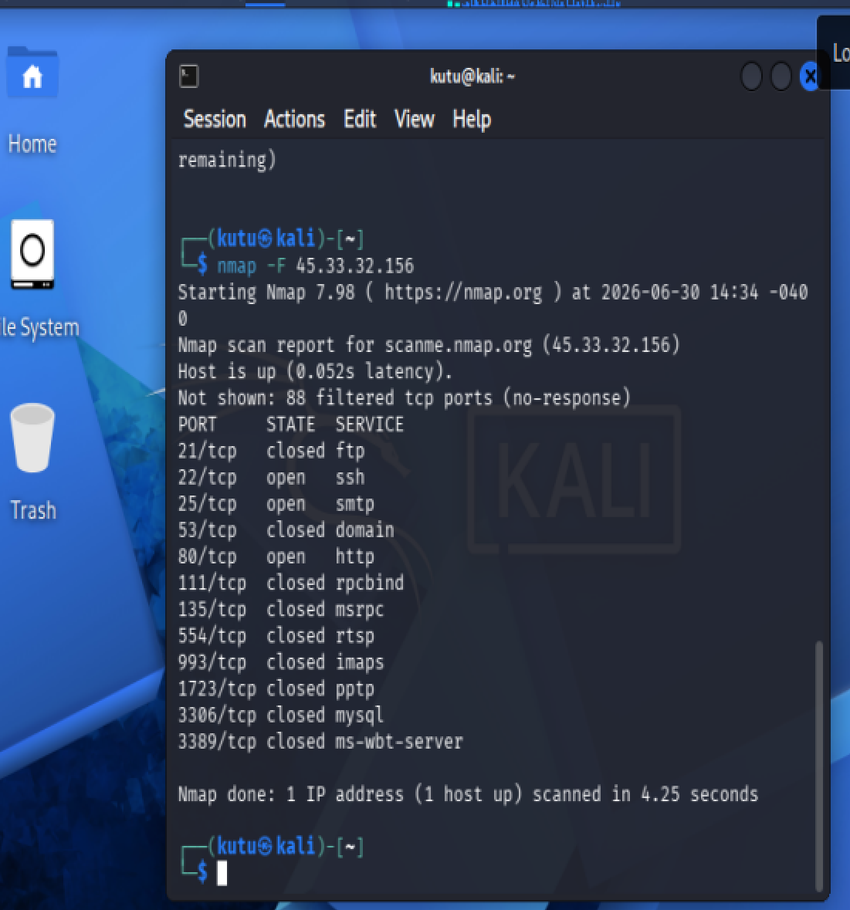
88 filtered TCP ports (no-response)
This means most of the scanned ports did not respond, which is commonly due to firewall filtering or access control.

Analysis
The scan identified three open TCP ports on the target host:

Port 22 (SSH)
SSH (Secure Shell) is used for secure remote administration of servers.

Port 25 (SMTP)
SMTP (Simple Mail Transfer Protocol) is used to send email between mail servers.

Port 80 (HTTP)
HTTP is the standard protocol used to serve web pages.

Most of the remaining ports were either closed or filtered, indicating that the server exposes only a limited number of services and likely uses firewall rules to restrict access.
conclusion
This experiment demonstrated how Nmap can be used to perform network reconnaissance by identifying open and closed TCP ports on a target host. The scan successfully detected the services available on the authorized practice server. Understanding which ports are open helps security professionals assess the network exposure of a system and identify which services require proper security management.

